**IMAD511w**

# **Assignment 1**

Heath Horn ST10468370

**A Meal for Your Time Application Report**

**Overview**

A Meal for Your Time is an application that was designed for the purpose of building a relationship between food and the consumer. The application focuses on suggesting meals for specific times of the day. These meals suggestions are based on the time of day the client would like to eat. Our client will prompt the app with specific inputs based on what time of day it is. These inputs are; Breakfast, Mid-morning snack, Lunch, Afternoon snack, Dinner and . The client will in return, receive a suggestion and advice on what to consume. Not only will these suggestions help the consumer build a strong eating schedule, but it will provide the customer with the opportunity to restructure their eating plan. The application’s suggestions are aimed at sustainable and healthy eating and in turn a better lifestyle

**Design considerations**

When developing the app, the customer’s perspective was the focus. The app was designed to make the experience of the user an easy one. With easy-to-understand feedback and consistency in flow, the user be able to use the least amount of cognitive energy and effort.

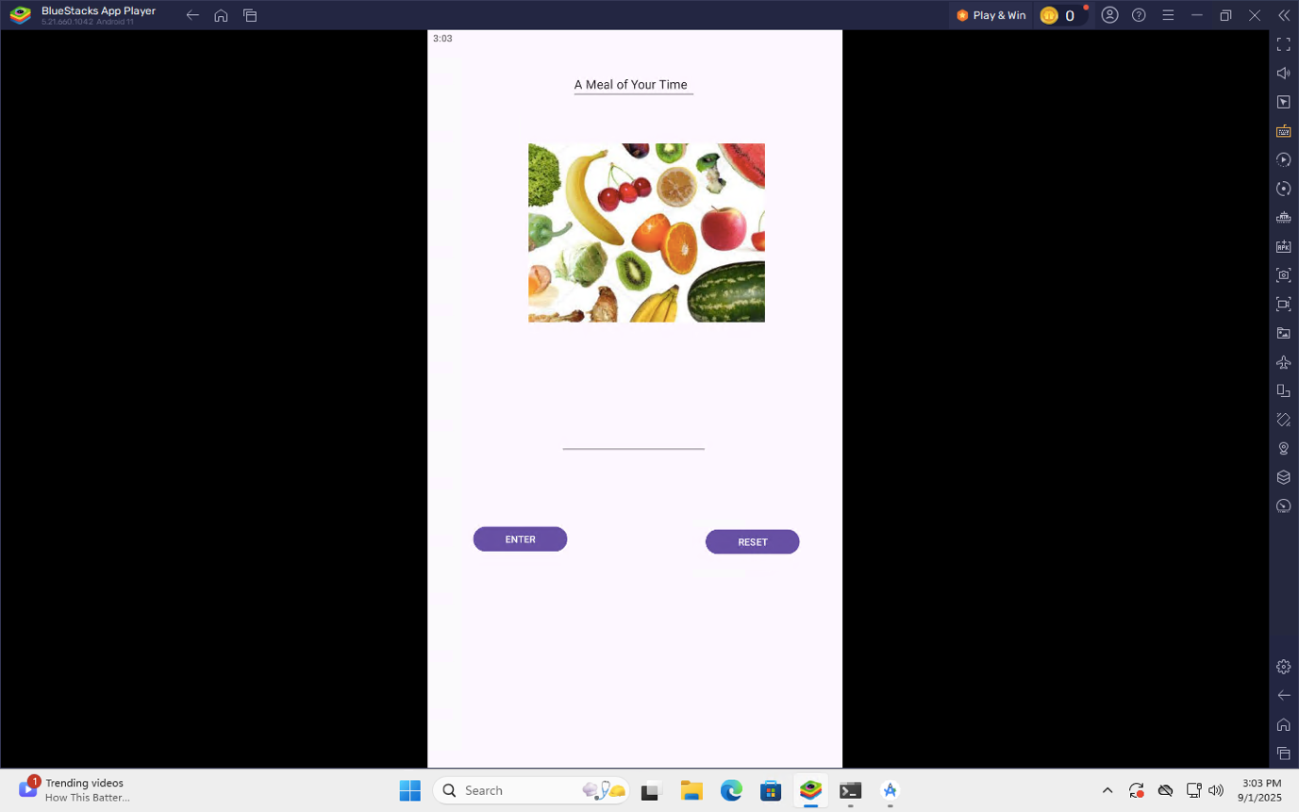

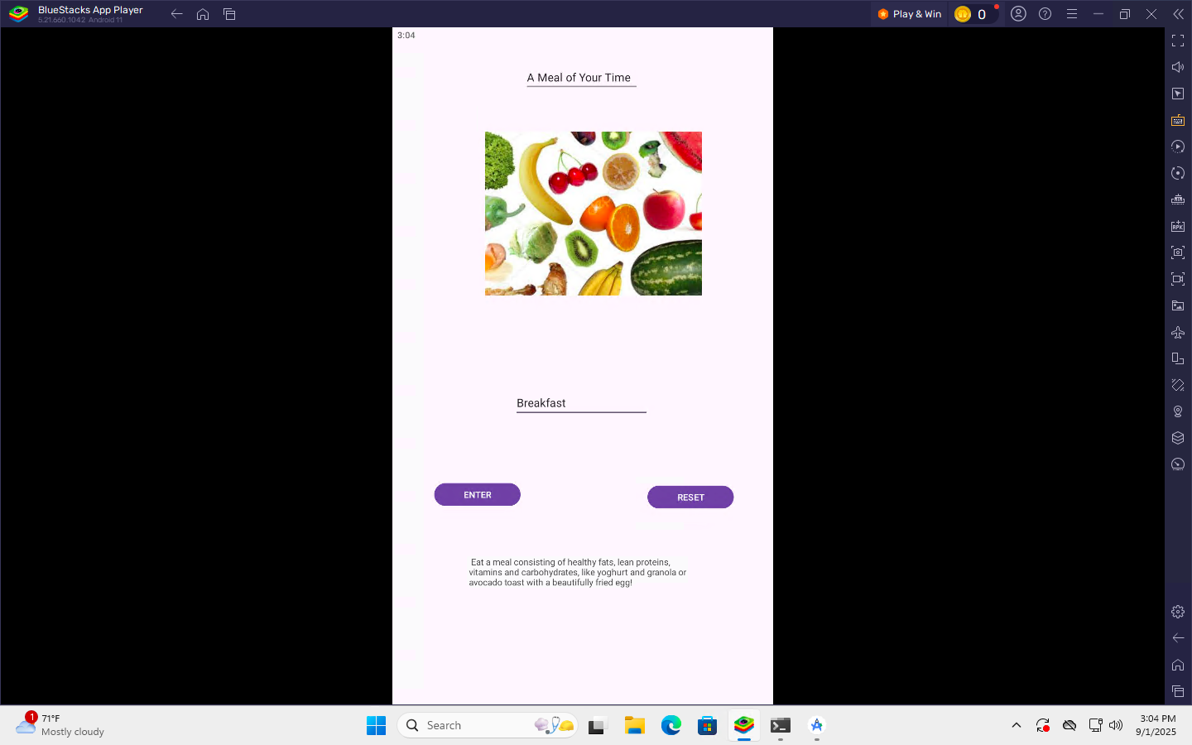

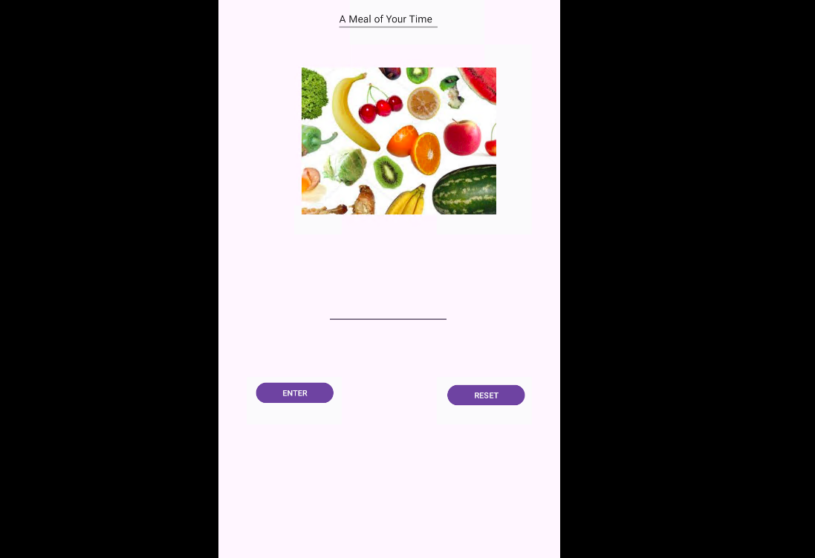

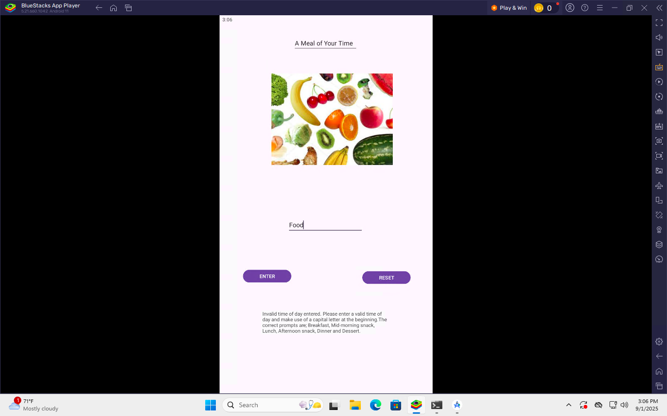

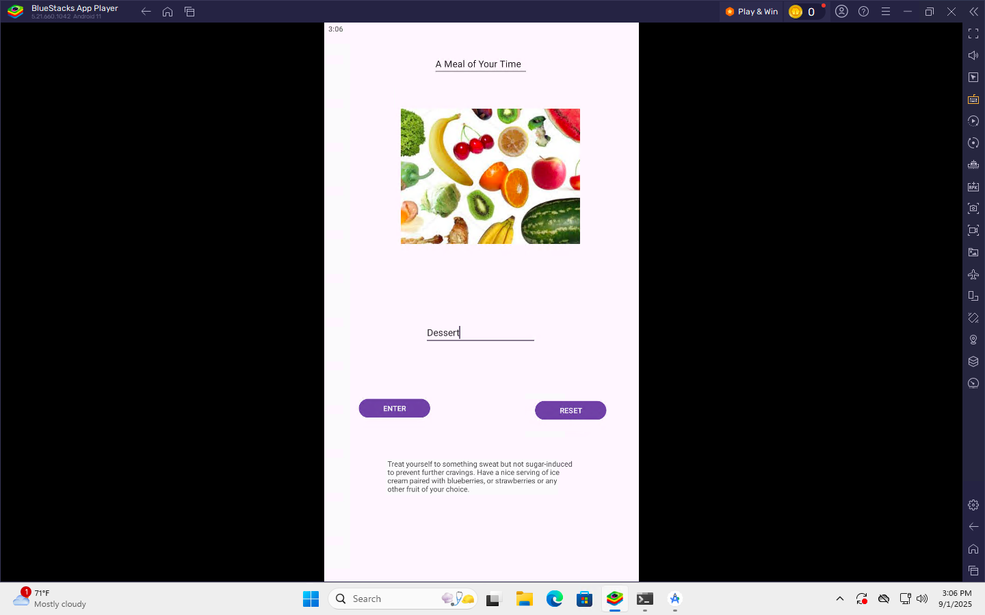

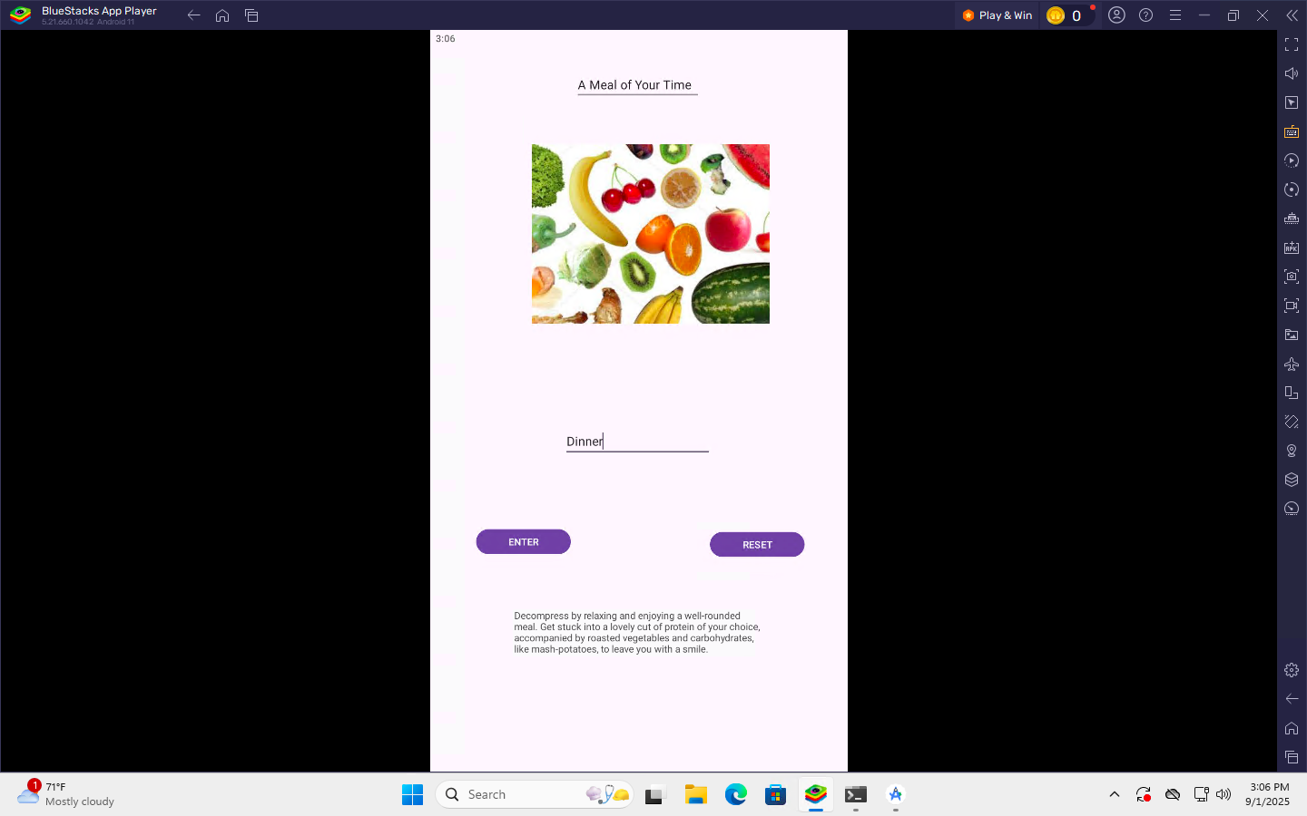

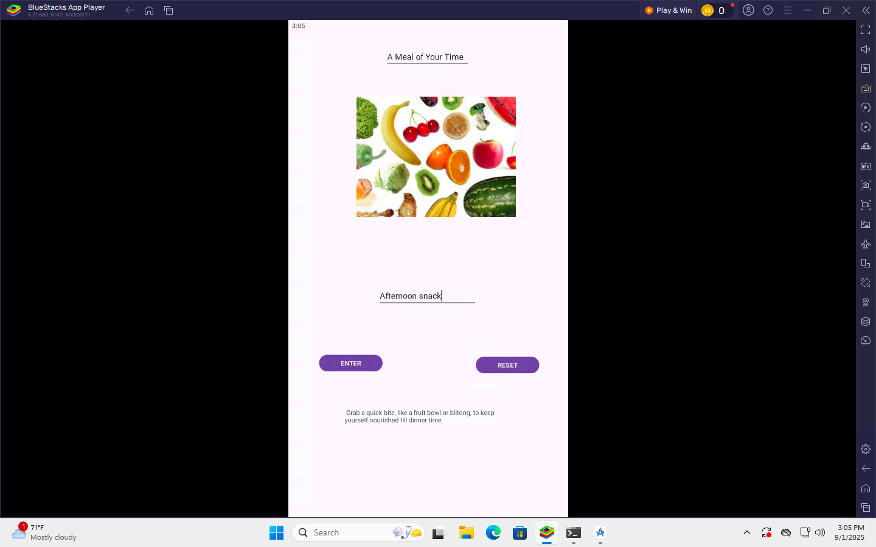

Github Link

https://github.com/ST10468370/ASSIGNMENT-1-IMAD511W-ST10468370

Youtube Link

<https://youtu.be/QJqUAnQ9KBU>

References

https://github.com/ST10468370/ASSIGNMENT-1-IMAD511W-ST10468370